Microstructural Effect of Iron In Titanium Zirconium Alloys

Submitted by
JAMJALA MANEELA
Semester: IXth
Regd. No: CUJ/I/2016/INT/032
In the fulfilment of IXthsemester examination
Integrated M.Tech in Nanotechnology

Dr. Arnab Sankar Bhattacharyya
(Internal Supervisor)
Department of Nanoscience and Technology
Central University of Jharkhand, Ranchi

Dr. A. K. Pramanick

(External Supervisor)

Principal Scientist (CSIR)
MTE Division
National Metallurgical Laboratory, Jamshedpur

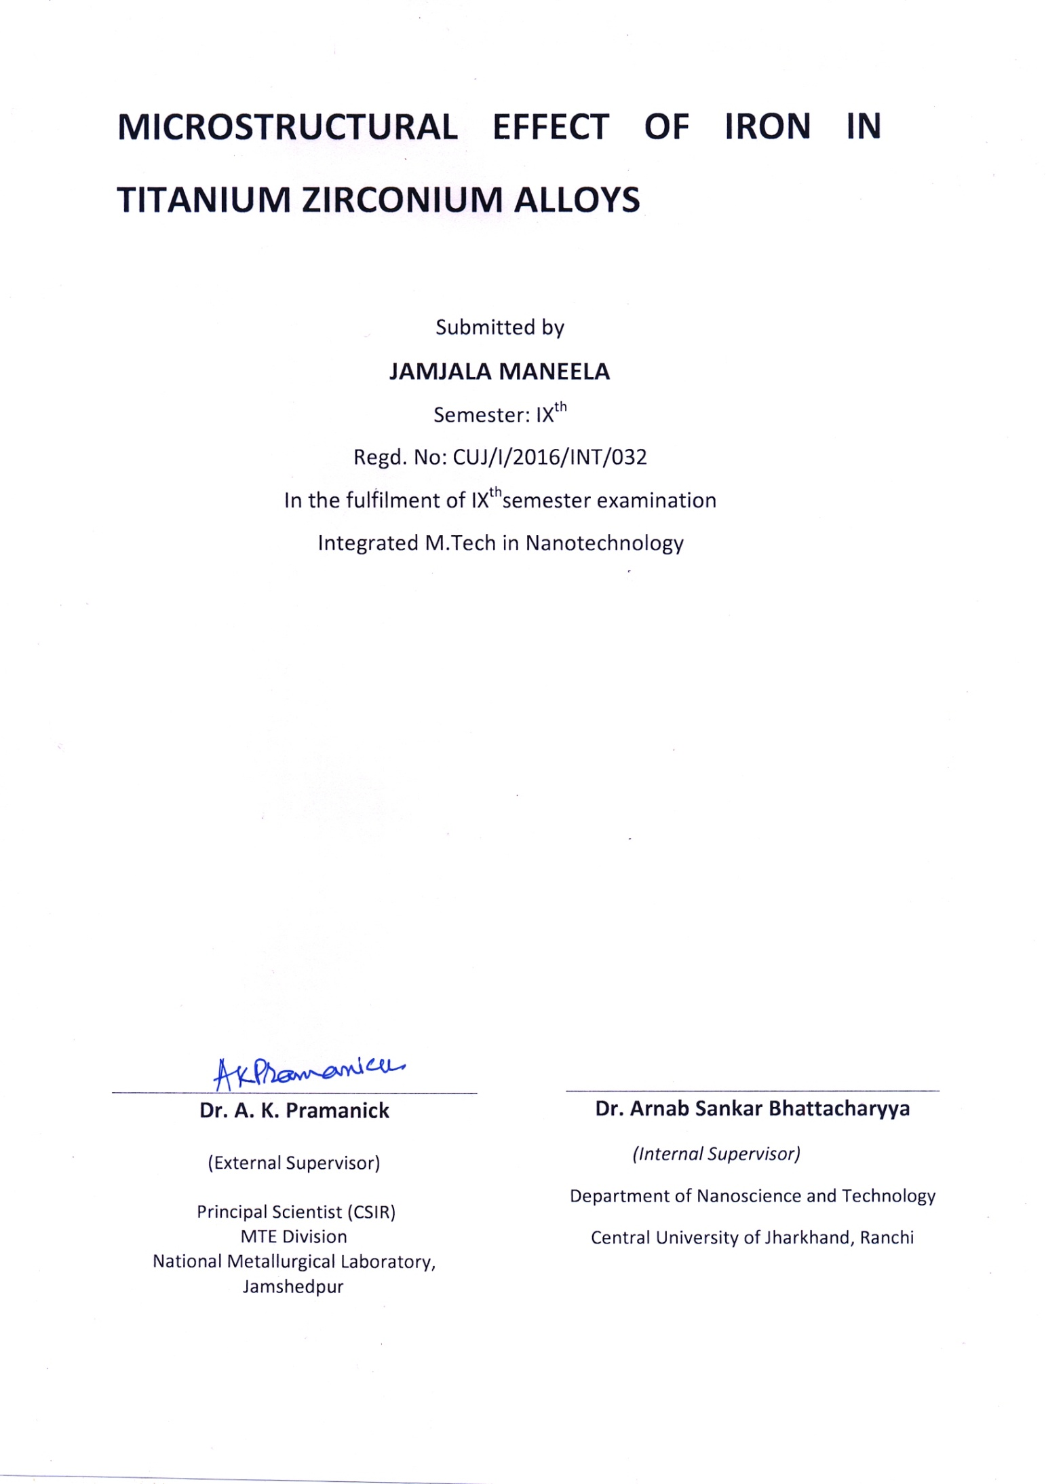
Declaration
I certify that
a. The work contained in this thesis is original and has been done by myself under the general supervision of my supervisor/s.
b. The work has not been submitted to any other Institute for degree or diploma.
c. Whenever I have used materials (data, theory and text) from other sources, I have given due credit to them by citing them in the text of the thesis and giving their details in the reference section.


Signature of the Student

CONTENTS Page no
Symbols and abbreviations 1
List of figures 2
1. Introduction 3
2. Literature review 4
2.1 Titanium and its alloys 4
2.2 Zirconium and its alloys 4
2.3 Effects of alloying (Titanium & Zirconium) 5
3. Phase diagram of Ti&Zr 6
4. Microstructure and properties of titanium 8
4.1 Other process for enhancing phase properties 8
5. Omega phase formation in titanium zirconium alloy 9
6. Effect of Iron(Fe) in titanium zirconium alloys 9
7. Experimental preparation of Alloy 11
7.1 Schematic representation of alloy preparation 12
8. Applications of Titanium zirconium alloys 13
9.Future works 14
8. References 15

ABSTRACT
The report starts with an introduction of basic concepts of some metals are titanium, zirconium, iron, molybdenum etc, which exhibit excellent physical, chemical and mechanical properties after alloying. Design and implementation of these kind of alloys possible by metallurgical development for different compositions required.
Many reactive metals are difficult to prepare in pure form without complex procedures. Alloy development is the key factor for development of better materials for engineering applications.
To maintain the superior biocompatibility, corrosion resistance etc of some alloy elements especially in biomedical implants and consumer applications like eye glasses, wrist watches are becoming major attaraction for human kind in the present days due to excess skin allergies caused by metal ions reactions of biomedical implants
Further, the most important characteristic property before alloying has to be considered is corrosion resistance. As no metal, or alloy, is entirely inert to corrosion, it is important to understand the characteristics before using it in any applications.
The result indicates that addition of iron in Zirconium improves the effect of β-phase stability and improves the properties of titanium zirconium alloys for many applications. Hence we proposed to study the phase behaviour of the Zr-Ti-Fe alloy along with characterization of the alloys.
Hence in this MTech thesis we focus on the effect of iron on (Zr-Ti) alloy and microstructural and mechanical properties. In this study, alloys are to be fabricated by arc melting followed by polishing and etching treatments to achieve observe optical microstructural effect of the alloys. Further alloys will be characterised by X-ray diffraction, SEM micro hardness and TEM.

Symbols and Abbreviations
α phase : Hexagonal close packed
β phase: Body centered cubic
α’ : Hexagonal close packed Martensite
α”: Orthorhombic Martensite
ω: Hexagonal (both in Titanium & Zirconium)
ω’ : Body centered cubic (Zirconium)
M_{p}:Melting point

LIST OF FIGURES
Figure 1 Phase diagram of Titanium Zirconium………………………........................7
Figure 2 XRD patterns for Ti₁₂Mo₆Zr and different addition of Fe alloy………..10
Figure 3 Schematic representation of experiment (Ti₉₀Zr₁₀)..................................12
Figure 4 Microstructure of theTi₉₀Zr₁₀alloy………………………………………...13

- INTRODUCTION

A new alloy development is a key focus in present days for many consumer applications. To achieve this type of alloys, metallurgical development alloys of improved corrosion resistance has been considered.
New Titanium type alloys has developed to meet the demands out of emerging applications in eye glass frames, wrist watches, dental treatments also many biomedical implants. Alloying element should be more resistant to corrosion, high elasticity, improved strength etc. Addition of Zirconium is effective for grain size refinement[1]. Such that alloy shows excellent cold workability and improved strength elongation balance compared to pure commercial Ti due to fine grain.
Another important type of alloys have to be considered i.e. Intermetallics. Metal combines to form compounds which has a crystal and grain structure different from commercially pure metals. Intermetallic compounds are generally hard, brittle. Such alloys with small amount of intermetallic compounds are valuable, such alloys combine the toughness of solid solutions with the hardness of intermetallic compounds.
Among metallic materials, titaniumand its alloys are considered the most suitable materials in medicalapplications because they satisfy the property requirements better
than any other materials, like stainless steels, Cr-Co alloys, commercially pure (CP) Nb and CP Ta[2].
Fe has been selected due to its low cost aswell as one of the strongest β -stabilising agent in titanium which enhances properties for Titanium alloys. The alloy developed for the titanium zirconium in presence of iron to achieve some essential properties in applications. Commercially pure titanium does not meet the demands to prevent surface scratch on products as well as to achieve more sophisticated design. Hence alloying element enhances the properties like cold workabilitiesto apply in many consumer goods.
On the other hand, mechanical properties of alloys are very important to be considered for effect of alloying. For example when a implant is required to replace a tooth generally small diameter implants are preferred(<3.5 mm)[3]. The reduced diameter implants shows high risky of fatigue fracture. So it is possible to develop a small diameter implants with titanium alloys which have excellent mechanical strength.
In the following a brief introduction to titanium zirconium alloys, effect of iron when alloyed to titanium zirconium, their microstructural effect, especially phase properties of alloy formation, and their application in the field of consumer good applications as well as biomedical implants has been presented. Experimental techniques to prepare alloys have been discussed. Finally, the planned work in future has been reported.

2. LITERATURE REVIEW
2.1 TITANIUM
Titanium is a transition metal.Titanium is broadly used in many fields including aerospace, power generation, automotive, chemical and petrochemical, sporting goods, dental and medical industries etc. The large variety of applications due to its excellent properties like
- High strength,
- Low density
- Corrosion resistance
- Biocompatibility,
- Mechanical behaviour.
Among many other materials titanium and its alloys are considered more suitable materials in medical applications. Since commercially pure titanium and titanium alloys do not meet the demands for medical applications, a new type of alloys has been reported, that is β type alloys. [2-5]
Recently β type titanium alloys have great demand because of excellent properties. After heat treatments this type of alloys exhibits
- low elastic modulus,
- very good corrosion resistance,
- high strength
- good biocompatible behaviour.
Addition of zirconium to β titanium alloy has more promising properties of increasing superelasticity, maximum relative strainetc[6].
Titanium is a polymorphic metal (can occur in several forms of alloys), exists in two allotrophic modifications with different crystal lattices.Both Titanium and Zirconium, at high temperature, termed as β phase, with BCC structure while the low temperature termed as α phase, which is closed HCP structure. Low temperature modification is (α titanium) has HCP i.e. below 882◦C. High temperature modification (β titanium) has BCC i.e. above 882.5◦C.

2.2 ZIRCONIUM

As like Titanium, Zirconium exists as hexagonal close packed α-phase at room temperature & pressure, at about 2Gpa exists as ω phase (Hexagonal).But in zirconium some pressure experiments at room temperature havereported ω phase transforms to ω’ phase(BCC) same as β- phase[21]

ω-phase ω’ phase(BCC)

In the presence of 10% zirconium and hafnium in titanium temperature does remains practically constant. When the element content is higher than 10% we could find small decrease in temperature.
Zirconium has excellent corrosion properties as well as low neutron absorption capacity in hot water and steam, its good strength at high temperatures, high ductility is reasonable for high fabricability. The application of Zirconium is highly expanding in chemical process industries due to increased relative prices of alternate material.
The reason for alloying zirconium with titanium tends to better phase transformations when alloyed because of the presence of β stabilizers in zirconium.

Zirconium is selected for the alloying element of titanium for four reasons:
- The tendency of Zirconium segregation during solidification is very small
- Zirconium is one of the attractive additional element to maintain biocompatibility of titanium alloy.
- Addition of zirconium tends to refine the microstructure of the alloy.
- No solubility limit for Zr in Ti matrix.

2.3EFFECT OF ALLOYING on Ti & Zr
The important effect of alloying of Ti- Zr pertains to allotrope α phase to β phase transition temperature.
Some impurities like molybdenum, manganese, hydrogen etc, which reduces the temperature of the transformation of titanium are β stabilizer. Impurities such as oxygen, nitrogen, aluminium raises the transition temperature of titanium are αstabilizers.
Generally in alloys, single phase α and single phase β is separated by a two phase α+β region.The single phase α to phase β transformation temperature in case of Ti&Zralloy is associated with α & β transition temperature.
- α transition temperature: the temperature below which the alloy contains only the α phase.

- β transition temperature: the temperature above which the alloy contains only the β phase.In between these two temperatures, both α and β phase are present.
Under atmospheric pressure, titanium
α-phaseBCC (β) phase

3. PHASE DIAGRAM OF TITANIUM ZIRCONIUM ALLOY
A pure element represents a single component which may exhibit different phases. The melting point of titanium is 1668○C and the melting point zirconium is 1852○C[9]. Titanium and zirconium can form continuous solid solutions, similar in their structures as well as atomic diameters because of similar properties. Generally the transition temperature of the titanium alloy in solid state decreases with increase in zirconium concentration.β phase in titanium zirconium alloy is not retained at room temperature, because martensite transformation of β phase into α’ phase occurs during quenching. To inhibit the β to $α^{'} phase$ transformation in alloys of Ti-Zr, high rate of cooling is given (100-8000 degree/sec). Partial transformation of β phase to α’ phase even occurs at high rate of cooling.
Martensite transformation from β to α’ phase occurs during cooling in β- region , on heating the same transformation can occur from α’ to β phase.X- ray analysis shows that only martensite α’- phase retained afte the rapid cooling(quenching) of this alloy system at the rate of 1000-1500 degree/sec.At this time, the β phase could not be detected in alloys even have equal content of zirconium. Under the condition of the rate of cooling about 200-300 degree/sec, some of the β phase supercooled to the temperature forms β to ω transformation.
During heating, this process of formation may be reversed.The ω to β transformation and α’ to β transformation can beobserved when heating of quenched alloys. Under the condition of the rate of cooling about 200-300 degree/sec, some of the β phase supercooled to the temperature forms β to ω transformation. During heating, this process of formation may be reversed.The ω to β transformation and α’ to β transformation can observed when heating of quenched alloys.
The melting was carried by an arc furnace in inert atmosphere, and finally annealed.The nature of hardness of Ti- Zr alloys at room temperature follows the same pattern.
Mechanical properties of Ti- Zr alloy has determined with the increase of Zirconium content the tensile strength of the alloy increases, decreases when zirconium content decreased.
The addition of 10% Ti to Zr, and 8% Zr to Ti, increases the tensile strength of the alloys. At this region of alloy exists as α-solid solutions, as increasing the degree of alloying the alloys are transformed into binary alloys (α+β), where this is done by a decrease in tensile strength.
Hence it concludes that the tensile strength of alloys in β solid solution is very low and constant.The uniform creep rate of Ti – Zr alloys were carried out at 500, 600, 700 degrees and under a load of 1 kg per mm square.Creep rate increases when the alloys of various compositions enter the binary region, particularly β solid solutions.
ω-phase obtained from α phase by the application of pressure in Titanium & Zirconium.Depending on solute concentration, ω phase structure is to be determined to be either hexagonal, or, trigonal.
In Zirconium, on application of higher pressure ω- phase transforms to ω’ – phase, which has BCC structure.

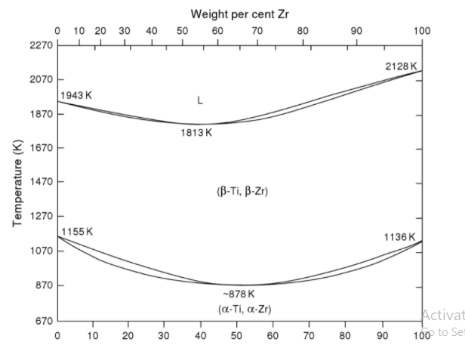
Fig.1 Equilibrium Phase diagram for Ti - Zr system

4. MICROSTRUCTURE AND PROPERTIES OF Ti - ALLOYS
Titanium is stable only at certain temperature ranges. At a temperature of 882 ◦C, pure titanium undergoes phase transformation from stable low temperature (α) to high temperature (β), which remains stable up to the melting point of 1678 ◦C.The main characteristics of crystal structure in the case of phase diagrams can be followed by plastic deformation capability and diffusion[14].
The diffusion rate depends on the lattice microstructure.Titanium and its alloys react with many interstitial elements.Such reactions may occur well below M_{p} temperature.Depending on some conditions α and near-α titanium alloys have different microstructural grain shapes/ structures.
This type of titanium alloys mainly used for high temperature applications in various fields.β titanium alloys generally contain the β stabilizers, sufficient for balancing β stabilizer to α stabilizer , shows effective β microstructure on fast cooling.
This type of metastable β type alloys generally have high strength , higher toughness, undergoes plastic deformation without damage at room temperature than α and α+βtype alloys.
4.1 OTHER ENHANCING PROPERTIESFOR PHASES IN ALLOYS
The control and morphology of theα phase is one of the important issues in Titanium.To overcome this problem, thermomechanical processing techniques are used for modifying microstructures (e.g.controlling size of α phase, to improve the efficiency ratios of α to β phases, also controlling the structure of β phase.
- Thermomechanical processing [10,11]: In this process generally alloys are subjected to two types of treatments
- Production of usable shapes through primary working and secondary mill operations e.g. hot rolling or forging.
- Optimization ofmechanical properties through microstructure control during different stages of processing.
- Powder metallurgy [15,16]: Powder metallurgy is one of the emerging fields in recent days for the production of complex geometries without machinability. PM components are a cost-effective process and low environment impact to produce high strength parts.
Advantages:
- Less energy consumption
- Low relative material wastage
- Maximum material utilization.

- OMEGA(ω) PHASE FORMATION IN TITANIUM & ZIRCONIUM ALLOYS
The omega phase is metastable state forms in titanium zirconium alloys. The ω phase in general increases mechanical properties, strength and the reduction in ductility.More recently there has been much improvement in superconducting properties of titanium and zirconium alloys with omega phase precipitation i.e. large increase in critical transport current densities in external magnetic field obtained only through ω phase[12].
ω-phase is observed in which high-temperature bcc phase can be continued in a metastable state at low temperatures by rapid cooling.It is observed in all titanium – zirconium alloys processed at high temperatures.
Omega phase formation is observed occur under three desirable conditions are:
- Omega precipitation occurs during quenching in most systems over a limited range of alloy content when close to the lower limit of β- phase.
- Omega phase forms during ageing in higher alloy contents at high-temperature range i.e. 100 to 500○C.
- Deformation at room temperature produces omega phase in some circumstances.
In some systems in which β phase is stable at room temperature for high alloy content, omega phase forms only when alloy concentration lower than equilibrium.
Many β stabilised titanium zirconium alloys have excellent superconducting transition temperatures and properties.These are generally Type II superconductors with suitable metallurgical preparation, they can sustain high maximum zero resistant transport current(J_{c}) inthe high magnetic field (H) due to the presence of microstructural features[13].

6. EFFECT OF IRON IN TITANIUM ZIRCONIUM AND OTHER ALLOYS[14]
Previous works have suggested that the addition of zirconium and a small amount of Fe improves the β-phase stability and improving properties of titanium molybdenum alloys.Especially Alloys of Ti12Mo6ZrxFe has excellent properties for biomedical materials used in dental implant application. [x=1,2,3,4wt%].Although titanium, there are many elements which exhibits excellent corrosion resistance properties, good biocompatible behaviour especially in biomedical applications i.e. Zirconium, Molybdenum, Tantalum, Niobium, etc.
Among these materials, Molybdenum has the strongest effect on β- stabilization on titanium alloys other than Ta or Nb.Also it has a high modulus of elasticity and lower melting points than tungsten and tantalum.Molybdenum is a valuable alloy, contributes for the hardening and toughening of steel.
Moreover addition of Zirconium, and a small amount of Fe improves β-phase stability i.e.more corrosion resistance compared to other alloys, also improves mechanical properties of Ti-Mo alloys[17].Zirconium is considered as an alloying agent in newly developed Ti alloys for biomedical applications.
Fe has been selected due to its low cost as well as one of the strongest β stabilising agent in titanium which enhances more attracting properties for many applications mostly in Ti- Nb alloys.
From the previous experimental results of Ti₉₀Zr₁₀ alloy mainly consisted α’+β phase, on adding the Fe content greater, β-phase completely retained with BCC structure because the stabilizing effect of beta phase by Fe[18].
In case of iron, allotropic transformation is the main reason for variety of microstructure in titanium alloys.If the β stabilizer is considered to be low, then rapid cooling leads to the formation of hexagonal martensite(α’).
When the β stabilizer content is high, then α’ martensite undergoes distortion, loses its symmetry, becomes orthorhombic martensite(α”)[20].

7.EXPERIMENTAL PREPARATION OF ALLOY
In this section, brief details of experimental methods are presented. Melting was carried out in induction arc melting. Metals of titanium and zirconium with different compositions are melted using an inert gas atmosphere was created in sealed quartz tube have openings for gas flow and crucible inside of the assembly. The assembly was kept between induction coil for melting. Induction current was increased slowly for melting of the alloy.
Melted alloy was cut and polished using a grits of (220-320-1000-1200µm), with final polishing conducted by a cloth polishing method. Metallographic studies of the microstructure of the etched state analysis was performed on the optical microscope as well as scanning electron microscope[25]. For the analysis of microstructure, etched in a solution of hydrofluoric acid(5ml), nitric acid(5ml) acids, with a glycerol base(15ml).
7.1 Microstructural investigation
The structure and composition of the alloying element were evaluated using a optical microscope. Optical microscope uses a visible light and a system of lenses to magnify images of small samples.
The investigation performed at resolution about 500µm, 200µm, 100µm. Figure 4 shows the microstructure of Ti₉₀Zr₁₀ after etching treatment in concentrated solutions. Fine microstructure is obtained as predicted by figures below at different resolutions.
Microhardness, SEM, XRD analysis to be done further.

7.2 Schematic representation of titanium zirconium alloy (Ti₉₀Zr₁₀)
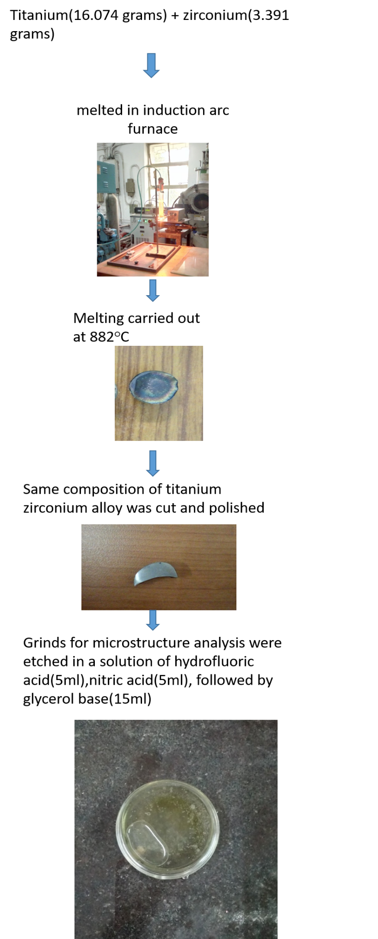

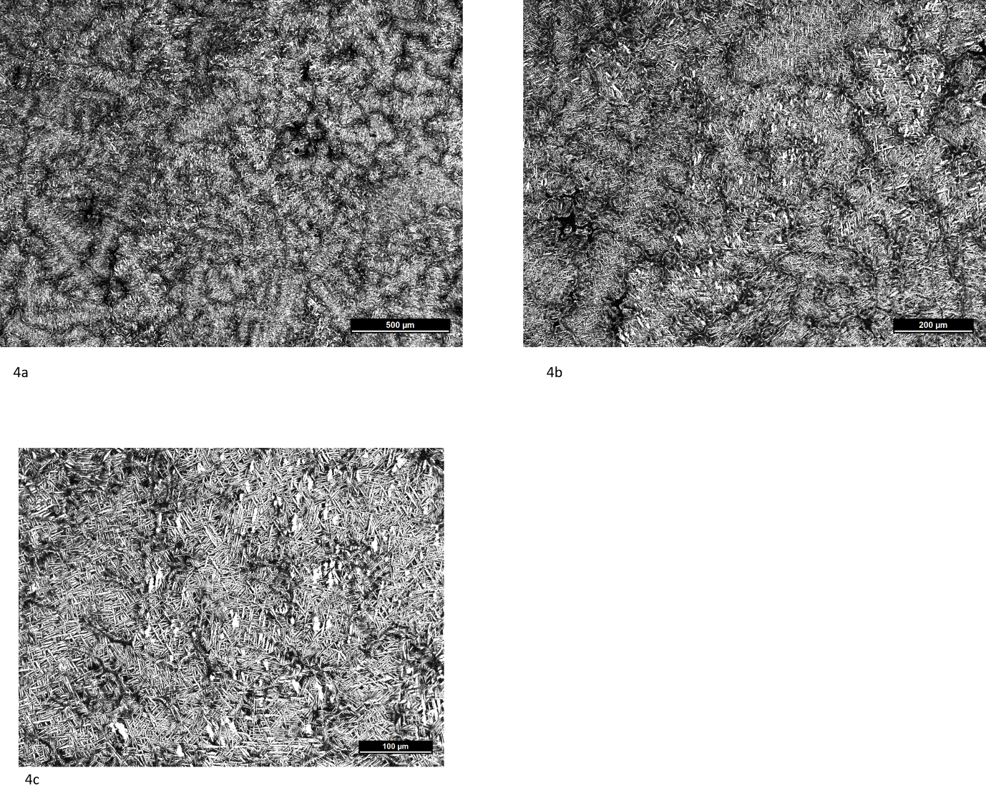
Fig 4a 4b 4c shows the microstructure of Ti₉₀Zr₁₀ alloy

8.APPLICATIONS OF TITANIUM ZIRCONIUM ALLOYS
- Biomedical implants: Ti alloys has been using for the purpose, with high clinical success and due to their higher life expectancy, implants that expected to serve for many longer periods.[26]
- Consumer goods: The demands of eye glasses and wrist watches are increasing, due to the concern at skin allergy caused by Nickel, hence to achieve high strength and high resistance materials to prevent allergies, titanium along with zirconium alloys are used to achieve more sophisticated properties which exhibits excellent properties of high workability and high strength.
- Stents: Stents are most rapidly growing cardiovascular cylindrical mesh tubes which are developed for inserting into blood vessels, hence titanium based alloy stents are used to make blood vessel easier for treating cardio-vascular problems.
- Aerospace applications: Zirconium alloys are preferred for aerospace applications which shows lower neutron absorption per unit strength than other structural materials[6].
- Dental and orthopaedic implants: Titanium’s corrosion resistance both in air and biological fluids, which propagates biocompatibility on its surface. It favours osseointegration with surrounding bone tissue in both dental and orthopaedic implant applications.
- Ferrotitanium[29] : A well known hydrogen storage material and very fast emerging as eco- friendly energy source in 21st century. It aims to produce structural material with less metal and excellent property of higher mechanical strength.

Applications involved with this type of metallurgical alloys are
    - Steel and stainless steel processing units.
    - Additives for making special steel & flux-cored wires.
    - Military and commercial aircrafts.
    - Paints, varnishes, and lacquers

FUTURE WORKS
Future work includes
1. Alloy preparation by Arc Furnace
2. Alloying effect of Iron (Fe) in Titanium(Ti)-Zirconium(Zr) alloy
3. To explore microstructural effect of Fe addition in (Zr-Ti)_{100-X}Fe_{X} alloy
4. Microstructural Characterisation by XRD, SEM, TEM and AFM
5. Mechanical property study-Hardness
6. Final report will be made and submitted.

REFERENCES
[1] Nakasuji, K.; Okada, M., Mater. Sci. Eng. A1996, 213, 162–165.
[2] Sibum, H., Adv. Eng. Mater.2003, 5, 393–398.
[3] Wang, K., Mater. Sci. Eng. A1996, 213, 134–137.
[4] Rack, H. J.; Qazi, J. I., Mater. Sci. Eng. C2006, 26, 1269–1277.
[5] Niinomi, M., Metall. Mater. Trans. A2002, 33, 477–486.
[6] Northwood, D. O., Mater. Des.1985, 6, 58–70.
[7] Jiang, X. J.; Zhou, Y. K.; Feng, Z. H.; Xia, C. Q.; Tan, C. L.; Liang, S. X.; Zhang, X. Y.; Ma, M. Z.; Liu, R. P., Mater. Sci. Eng. A2015, 639, 407–411.
[8] Cahn, R. W., Pergamon Materials Series; 2007; Vol. 12.
[9] Akira, P.; Kuroda, B.; Afonso, M.; Buzalaf, R.; Grandini, C. R., Elsevier2016.
[10] Titanium Alloys: Modelling of Microstructure, Properties and Applications - W Sha, S Malinov.
[11] Weiss, I.; A, S. S.-M. S. and E.; 1999, U., Elsevier.
[12] Weiss, I.; Semiatin, S. L., Mater. Sci. Eng. A1998, 243, 46–65.
[13] Hickman, B. S., The formation of omega phase in titanium and zirconium alloys: A review. J. Mater. Sci.1969, 4, 554–563.
[14] Alden, T. H.; Livingston, J. D., Appl. Phys. Lett.1966, 8, 6–7.
[15] Mohan, P.; Elshalakany, A. B.; Osman, T. A.; Amigo, V.; Mohamed, A., J. Alloys Compd.2017, 729, 1215–1225.
[16] Ye, X. X.; Chen, B.; Shen, J. H.; Umeda, J.; Kondoh, K., J. Alloys Compd.2017, 709, 381–393.
[17] Li, B. Q.; Wang, C. Y.; Lu, X., Mater. Des.2013, 50, 613–619.
[18] Nag, S.; Banerjee, R.; Fraser, H. L., Materials Science and Engineering C; Elsevier, 2005; Vol. 25.
[19] Niinomi, M.; Akahori, T.; Katsura, S.; Yamauchi, K.; Ogawa, M., Mater. Sci. Eng. C2007, 27, 154–161.
[20] Balazic, M.; Kopac, J.; Jackson, M. J.; Ahmed, W., Int. J. Nano Biomater.2007, 1, 3–34.
[21] Dobromyslov, A. V.; Elkin, V. A., Mater. Sci. Eng. A2006, 438–440, 324–326.
[22] Nakasuji, K.; Okada, M., Mater. Sci. Eng. A1996, 213, 162–165.
[23] Veiga, C.; Davim, J. P.; Loureiro, A. J. R., PROPERTIES AND APPLICATIONS OF TITANIUM ALLOYS: A BRIEF REVIEW; 2012; Vol. 32.
[24] Phase Transformations, Volume 12 - 1st Edition.
[25] Mishchenko, O.; Ovchynnykov, O.; Kapustian, O.; Pogorielov, M., Materials (Basel).2020, 13, 1306.
[26] Long, M.; Rack, H. J., Titanium alloys in total joint replacement - A materials science perspective. Biomaterials1998, 19, 1621–1639.
[27] Balazic, M.; Kopac, J.; Jackson, M. J.; Ahmed, W., Int. J. Nano Biomater.2007, 1, 3–34.
[28] Michelle Grandin, H.; Berner, S.; Dard, M., Materials (Basel).2012, 5, 1348–1360.
[29] Panigrahi, M.; Paramguru, R. K.; Gupta, R. C.; Shibata, E.; Nakamura, T., High Temp. Mater. Process.2010, 29, 495–513.

