Effect of Al-alloy composition and foaming temperature on pore size, density and mechanical properties
V. C. Srivastava, Mirtunjay Singh, Tipu Kumar and K.L.Sahoo
National Metallurgical Laboratory, Jamshedpur-831007, India
Email: vcsrivas@nmlindia.org

Abstract

Sandwich aluminium foams were developed, with in-situ face sheets, by controlled powder forging and rolling. The parameters for forging, rolling and sintering were optimized for different combinations of Aluminium (Al), Al-12Si alloy, Al-8Si alloy and flyash. The foaming of the precursor was recorded and the expansion with time was estimated using image analysis. The growth of the sandwich could lead to ~350-400% increase in thickness, before melting of the face sheet, compared to the precursor without Al sheet that led to ~ 1000% expansion. The density varied between 0.35-0.90 g/cc and the average size of pores varied in the range of 2-5 mm. Compressive properties were evaluated and the total energy absorbed, up to 60% of deformation, was correlated with the density. The relation followed a power law with R² value of 0.95.

1 Introduction
Closed cell metallic foams have been sought as one of the promising materials for structural applications in the field of automobile, aerospace, railways, housing, acoustics and elevators etc. The light weight structures with efficient energy absorption properties, low thermal thermal conductivity and high sound attenuation are some of the highly acclaimed properties of the closed cell foams that make them a prominent candidate for the above applications, particularly Al-based metallic foams [1-3].
There are two different process routes by which closed cell can be synthesized e.g. liquid metallurgy route and powder metallurgy route [1, 4]. Foaming of liquid can be accomplished by direct foaming with gas, directional solidification and direct foaming with blowing agents. Foaming through powder metallurgy route is generally accomplished by using blowing agent in a powder compact which can be made by powder sintering, hot compression, powder rolling or extrusion.
Although a large number of reports are available on the powder metallurgy route of closed cell foam synthesis, only a few reports are available on powder forging and rolling technique to produce in-situ sandwich foams [5-6]. Therefore, in the present investigation, we have attempted to produce sandwich foam precursor by powder forging and rolling technique and study the foaming behavior of precursor foaming in terms of foam expansion with time and temperature. The density and pore size variation were evaluated with respect to process parameters such as alloy composition, foaming temperature and time.
2 Experimental Procedure
The powders for making precursors were having different compositions such as commercial purity Al, Al-Si alloy, Al-Si alloy + Al powder, Al-Si alloy + Al powder + flyash. Different combinations of powders were blended together along with different amount of foaming agent (TiH₂) ranging from 0.1 to 0.7 wt.%. The blended powders were canned and forged to a thickness reduction of about 70% followed by controlled rolling and sintering steps. Sintering was carried out at 450-500 ºC for 1-2 h so as to achieve dense sandwich precursor with approximately 0.5-1.5 mm thick face sheets.
Foaming was carried out in a resistance heating furnace at temperatures of 750, 800 and 850 ºC. A few of the foaming experiments were digitally recorded (high resolution videography) and the time dependent increase in thickness of foam was estimated using pixel counts. The expansion behavior was studied for different temperatures, compositions and thicknesses of precursor materials. The thickness measurement was done for the maximum height of the sample during expansion to avoid any effect of uneven sample expansion.
Density measurements of the foams were carried out by dividing the mass of the foam by estimated total volume of the foamed materials. The densities were calculated for the sandwich foams both with and without face sheets. The average thickness of the face sheet was taken into account for this purpose.
The samples for mechanical properties were made using electric discharge machining and the sample size was 15 mm in diameter and 15-19 mm in height. A cross-head speed of 5 mm/min was used for the measurements in compressive mode. The energy absorbed in the deformation was estimated by measuring total area under curve up to 60% deformation.
The size and distribution of pores were measured using image analysis as well as line intercept method applied on the foam structure. The samples for the observation of cell wall structure were prepared by filling the EDM cut foam surface with araldite and drying followed by standard sample polishing technique.
3 Results and Discussion
The results of the present investigation led to sandwich foams with 0.5-1.5 mm thick pure Al face sheets, as shown in figure 1. The thickness of the sandwich foams varied in the range of 12-20 mm and the average pore size was 2-5 mm.
The foaming behavior of precursor with and without face sheets was studied. It was observed that during foaming of a sandwich precursor, foaming takes place slowly and the face sheets remain intact. At a certain stage of foaming the aluminium face sheets starts melting from the sides and as the total face sheet get melted, further expansion takes place particularly in the centre of the foam (figure 2a). When the precursor is free of face sheet, the expansion takes place rapidly (fig. 2b) compared to those with face sheets (fig. 2a). The Al-12%Si alloy precursor does not lead to good foaming due to lack of proper sintering. However, an addition of 10-20 wt.% Al-powder in the Al-12%Si precursor leads to better foaming. This observation was made in both with and without face sheet precursor. The addition of flyash in the precursor without face sheet leads to better foaming and shows better stability as observed in the formation of large size pores in the range of 5-8 mm, although the number of pores decreases.
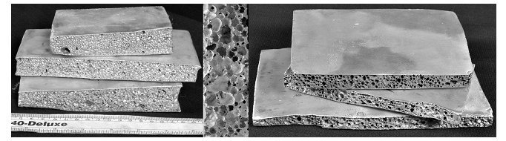

Figure 1: Sandwich foams with commercial purity aluminium face sheets along with typical pore morphology.
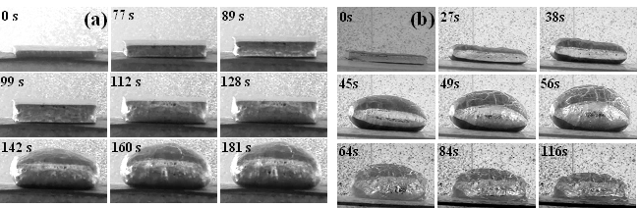

Figure 2: Sequence of foam expansion in Al-12%Si+10%Al precursors (a) with face sheets (b) without face sheet at 850 ºC.

The precursor without face sheets shows rapid response to heating and maximum expansion is observed after 56 s followed by collapse, whereas, the precursor with face sheets show maximum expansion at 128 s, with face sheet intact, and maximum expansion after 160 s. It was observed that the face sheet remain intact only up to a maximum of around 400% expansion. After this the sheet starts melting and further expansion takes place. When using alloyed precursor with low melting point, along with Al face sheets, the sheet does not melt until the precursor is melted. This is because the absorption of latent heat during melting of precursor does not allow heat accumulation in the face sheet.
The pore structure and average pore sizes of different foams are shown in figure 3. The reproducibility of the foam structure is always a difficulty. However, it was observed that flyash content up to 3% by volume led to uniform and large pores in Al as well as Al-8%Si. Larger Si content in the alloy or ex-situ flyash in the precursor led to poor sintering that does not give good foaming. However, addition of 10-20% Al powder in the precursor gives better foaming particularly in the sandwich foams where Al powder acts as cell wall stabilizer in a low melting point Al-Si alloy precursor.
(a)
(b)
(c)
(d)
(e)
The characteristic cell wall structures for the Al-8%Si and Al-12%Si+10%Al foams are shown in figure 4. It is observed that the foamable precursor and the face sheets has good interface bonding almost in all sandwich foams (fig. 4a). The Al-12%Si+10%Al precursor foaming showed large number of small pores in cell wall areas compared to that in the Al-8%Si alloy (fig. 4b). Therefore, generally the foamed structure seemed to have a bi-modal size distribution in these foams. When the holding time increases the number of pores in the cell wall regions decreased due to the coalescence of the small pores with the larger surrounding pores. The evidence of cell wall rupture and thinning are shown in figure 4c and 4d, respectively.
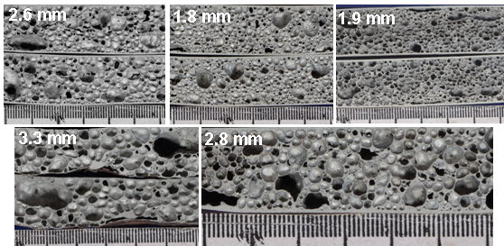

Figure 3: Pore structures, along with pores sizes, of Al-8%Si foams at 800 ºC (a) 2% flyash, precursor thickness 3.8 mm (b) precursor thickness 2.8 mm (c) precursor thickness 5.0 mm (d) 3% flyash, precursor thickness 2.8 (e) 2% flyash, precursor thickness 4.4 mm.
(a)
(b)
(c)
(d)

Figure 4: Cell wall structure (a & b) Al-12%Si alloy+10%Al powder (c & d) Al-8%Si alloy foam

The expansion behavior of precursors without face sheets was estimated by digital recording of the expansion process. It was observed that the expansion depends upon the thickness of the precursor. A rapid expansion takes place for thin precursor and maximum expansion can go up to 1000% of the original thickness whereas thicker sections could go up to only 700% expansion (fig. 5a). The effect of TiH₂ content and foaming temperature is shown in fig. 5b indicating increased expansion with increasing TiH₂ content. It was observed that TiH₂ content of 0.3% led to the best foam expansion and pore uniformity. Higher content of TiH₂ may give rise to coalescence of pores finally large and unstable pores. Similarly, increasing foaming temperature leads to higher expansion, particularly in pure Al precursors. In contrast, the alloy precursor with sandwich face sheets could lead to expansion of up to only 450% maximum. Figure 5c shows the expansion behavior of Al-12%Si alloy with foaming temperature, indicating almost similar expansion in all the cases except that at 850 ºC the rate of foam collapse is rapid, which is due to low viscosity at higher temperatures. The expansion behavior of various alloys containing 0.3%TiH₂ and foamed at 800 ºC is shown in figure 5d. This indicates that Al-8%Si alloy precursor has highest foaming possibility compared to Al-12%Si alloy. A mixture of 20% commercial purity Al powder in Al-12%Si powder improves the foamability of the precursor.
The compressive properties of the foams were evaluated at different strain rate (0.5-5.0 mm/min) and for different densities of foams. It was observed that such a range of strain rate variation does not affect the mechanical behavior and the stress-strain curve remained almost similar. However, a remarkable effect was observed with variation in density, as shown in fig. 6a. The energy absorbed up to 60% of deformation was estimated and plotted with density. The relation followed a power law with a R² value of 0.95. This showed a strong correlation between the foam density and the energy absorbed (fig. 6b). This observation is in contrast to that reported by Baumeister et al. [3], who showed a linear relation between energy absorbed per unit volume and foam density. However, the results of the present study is similar to that reported by Mondal et al. [7] and Hall et al.[8].
In the present study, three layered foamable precursor was made by simultaneous compaction of face sheets and powder blend. During foaming, the precursor melts and foams and is metallurgically bonded with the face sheet. However, even after melting of the face sheet a large expansion could not be achieved due to insufficient sintering of particles, particularly the alloy powders with Si. In case of pure Al powder, sintering is easier and a dense precursor could be achieved which led to large expansion up to 700-1000%. The addition of Al powder in the blend leads to better sintering in the Al-12%Si alloy and a better foaming is achieved. In addition, the pure Al particles in the growing foam, until the face sheet starts melting, might act as cell wall stabilizer due to the fact that the melting point of these particles will be higher than the foaming alloy.
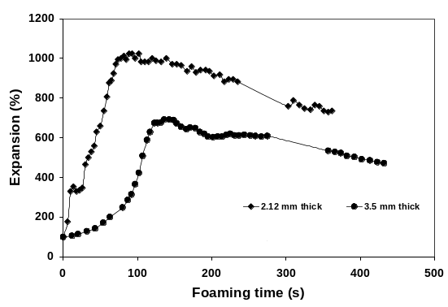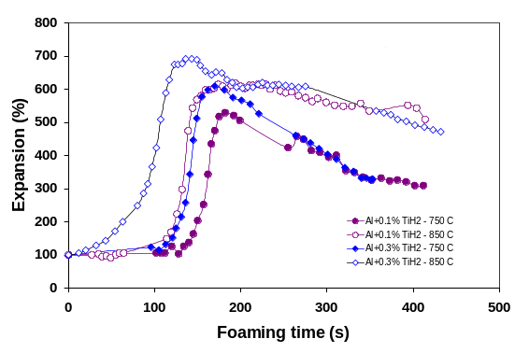
(a)
(b)
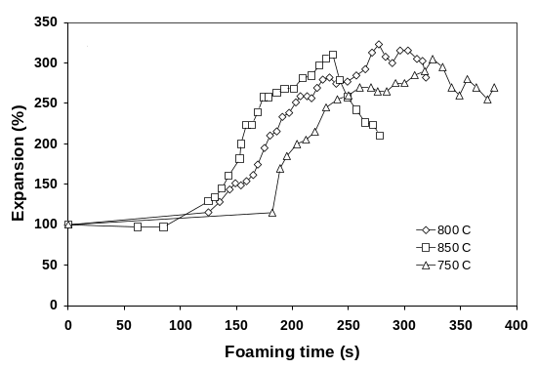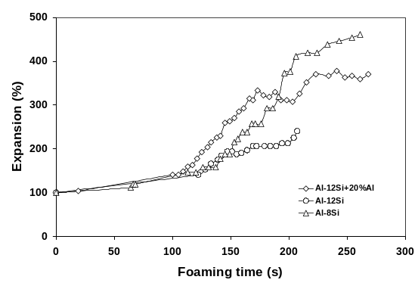
(c)
(d)
Figure 5: The expansion behavior of different foam precursors based on (a) thickness variation, without face sheets (b) variation of TiH₂ content, without face sheets (c) variation of temperature, with face sheets and (d) variation of precursor composition, with face sheets.

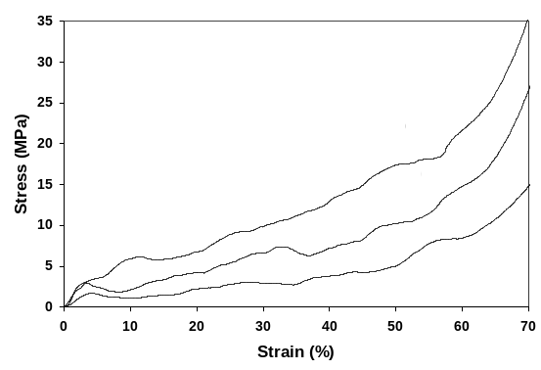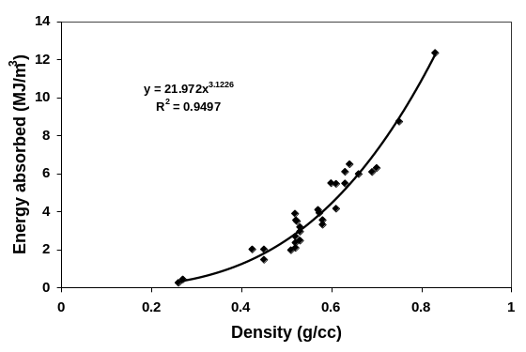
(a)
(b)
Figure 6:Variation in (a) compressive stress-strain curve with density (b) energy absorbed with foam density.

A large expansion of up to 1000% in thin precursor sheets may be attributed to the fact that the small mass per unit area on the bottom of the foam will not exert high pressure on the bottom pores and therefore, the chances of coalescence and collapse of the bottom section of the foam is avoided. Even the thinning of the cell wall due to expansion can support the exerted load on the cell walls. In contrast, it is speculated that due to insufficient sintering in the alloys, frequency of coalescence of pore will be high, and the formation of large pores due to pore coalescence will lead to rapid liquid drainage through the wall compared to that when the pores are small.
The technique for the measurement of foam expansion in the present case does show the results similar to those obtained by laser expandometer [9]. However, the pixel measurements for the assessment of the expansion in the present study may lead to some error, as the measurements rely on visual accuracy, in absolute terms. Despite this fact, the expansion behavior is more or less exact representation of the foaming stages.

4 Conclusions
In the present study, process for the in-situ sandwich foam formation is delineated. The effect of sample thickness, content of foaming agent, alloy composition and foaming temperature on foaming behavior has been brought out. A maximum of 1000% expansion is recorded during the foaming of thin precursor sheet of Al compared to only up to 450% for in-situ sandwich foams with alloy precursor. The compressive properties showed significant effect of foam density on the flow stress-strain behavior. The energy absorption up to 60% deformation showed a strong dependence, a power law correlation, upon the foam density.
5 Acknowledgments
The authors would like to acknowledge the financial support from Council of Scientific and Industrial Research (India) for this work, under the aegis of networked projects (NWP-0028) among its constituent laboratories.
6 References
[1] J. Banhart, Prog. Mater. Sci., 46, 559 (2001).
[2] L.-P. Lefebvre, J. Banhart, D. C. Dunand, Adv. Eng. Mater., 10, 775 (2008).
[3] J. Baumeister, J. Banhart, M. Weber, Materials and Design, 18, 217 (1997).
[4] V.C.Srivastava, K.L.Sahoo, Mater Sci.-Poland, 25, 733 (2007).
[5] J. Banhart, H-W. Seeliger, Adv. Eng. Mater., 10, 793 (2008).
[6] H-W Seeliger, Adv. Eng. Mater., 6, 448 (2004).
[7] D.P. Mondal, M.D. Goel, S. Das, Mater. Sci. Eng. A, 507, 102 (2009).
[8] I. W. Wall, M. Guden, C.-J. Yu, Scripta Mater., 43, 515 (2000)
[9] I. Duarte, J. Banhart, Acta Mater., 48, 2349 (2000).

